Business Process: Manual Order Process

Contact | Contact Person
Business Process Owner | Billing Operations
Subject Matter Expert(s) | Katherine Martinez, Natalie Herrera, Amanda De La Cruz, Jhoan Funez, Shannon Whitely
Key Contact | Maya Duarte
Key Role | CSR, Sr CSR, Revenue Analyst
Date Created | September 14, 2018

Business Process Overview
When customers request a move order that cannot be processed in CRM, Manual Orders are created through CRM by Customer Care. The typical move orders which require a Manual Order are Backdated moves and Restores.

Backdated moves are requested to establish service for a customer prior to the last billed date and Restores are requested to re-establish service for a customer whose service was closed in error. Other request for Manual Orders, may occur when the service address corresponding to the move order does not exist in SAP.

Billing staff shall only process Backdated moves and Restores, if they are due to a SMUD error. Once a Manual Order is received staff must process it within 3 business days to ensure timely and accurate billing.

Business Process Assumptions, Prerequisites, Dependencies
(Assumptions pertaining to the business process)
People | - Billing CSR, Sr CSR, Revenue Analyst  - Contact Center CSR, Sr. CSR, Supervisor
Process | - There must be a request made by a customer to backdate a move in  - A SMUD error has occurred, and a CSR has identified the SMUD error where a move in was not processed  - Approval is needed if not a SMUD error and A CSR has obtained approval from a Sr CSR or Supervisor to create a manual order for a backdated move in  - A CSR creates a manual order for a backdated move in that is assigned to Billing  - Accounts on the Developer Solar Shares program will be re-enrolled on the program prior to rebilling
Technology | - SAP, CRM

Process Flowchart
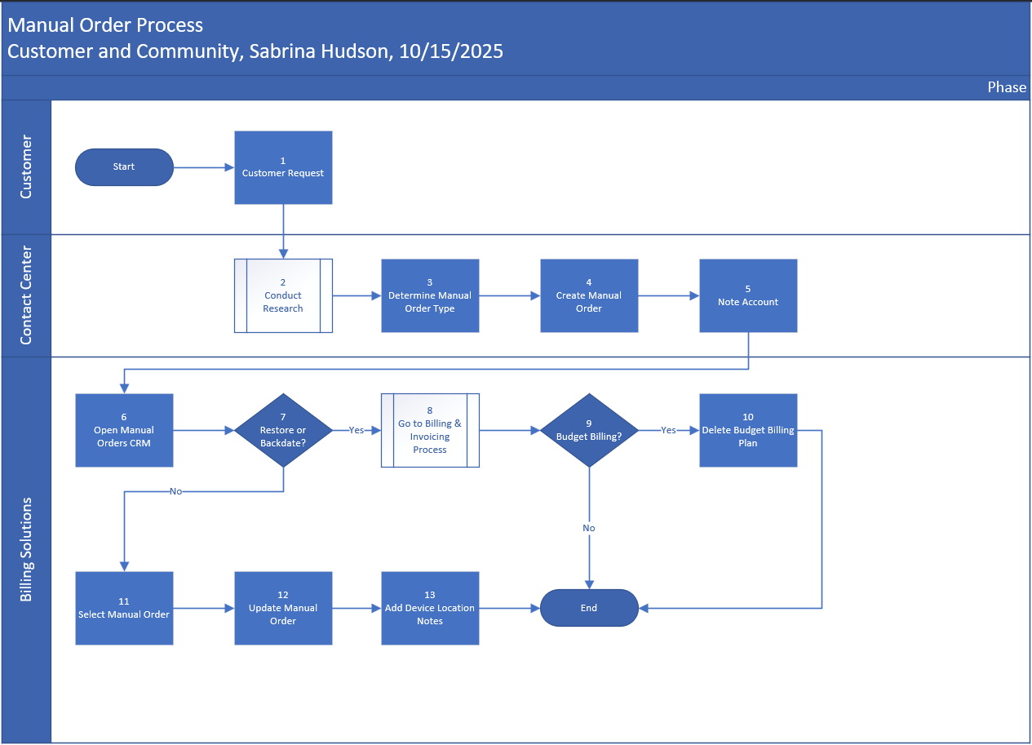

Task Description
Id | Task Description | Procedure
1 | Customer Request | - Customer call or email request
2 | Conduct Research | - CSR conducts research
3 | Determine Manual Order Type | - CSR determines which type of manual order to create
4 | Create Manual Order | - CSR creates manual order in CRM
5 | Note Account | - CSR notes customer account noting action taken
6 | Open Manual Orders in CRM | - Login to CRM  - From home screen, click on Work List work center  - Under Main Category, use drop down to select Manual Move Order  - Use one of the following Creation Periods:  - Today  - Last 3 days  - Last 7 days  - Note: You can also adjust the From/To dates if needed  - Click the Search button  CRM may take a few minutes to get the results  - Once results are returned, click on the “Search results are available” link to access the new Manual Orders  - In the results, if the status is:  - Open – you have a new Manual Order request  - Completed – no work is required
8 | Go to Billing & Invoicing Process | - Go to Billing & Invoicing process if manual order is a Restore or Backdate
10 | Delete Budget Billing Plan | If there is an active Budget Billing Plan:  - Access SAP transaction E61D  - Enter the Budget Billing plan #  - Click Execute  BBP will be deleted
11 | Select Manual Order | - Click on Manual Order under Main Category  - Click the Edit button to add notes:  - Important: Be detailed with notes and include BP#, service address, and meter #  Example: llopez, 2/20/20: Per MMO request submitted by (CSR or SNR header); Restored BP#123456 for 1234 Florin Rd, Unit 20. Customer was moved out in error. Billed account to current  - Click Save
12 | Update Manual Order | - Click drop down for Status and change to “complete”
13 | Add Device Location Notes | - Copy notes from Manual Order to the Device Location notes for each address corrected  - Click Save and Back  - Access SAP transaction ZCSBH  - Click on the Device Location #  - Click the pencil  - Click on the paper and pencil icon to add text  - Add notes, then click the back arrow  - Click Save, then click the back arrow

Business Rules
Id | Event Name | Business Rules
10 | Delete Budget Billing Plan | If customer is on Budget Billing, the plan needs to be dropped/deleted prior to the Move-In reversal
11 | Select Manual Order | - Manual orders should be worked daily  - 3 Business days to complete manual orders  - Must create separate Bill Docs and Invoices for Budget Billing accounts  - For Residential, Commercial, PV, EAPR accounts, create a separate Bill Document for each bill period and once Invoice Document  - ISA Accounts are not rebilled, CC Rep should PRAJ account if SMUD error  - If there is a credit on a final bill after performing a rebill, email Collections inbox  - If contract account number will not be immediately reused, dunning procedure must be changed to Z5 SMUD Final Bill Dunning  - If account balance is <$150, cancel manual order and inform Contact Center CSR to provide a PRAJ

Event | Legal Requirements, Rules, and Regulations  Legal documents/ procedures/ requirements to be fulfilled before/at the specified event.
Id | Event | Legal Requirements
N/A | N/A | N/A

Pain Points and Improvement Opportunities
- The form in CRM - it could be more clear or more user friendly/intuitive.
- CSR’s don’t complete the questionnaire stating the rate they should be on, if the other BP was f/o
- Fees/bill order reversals if its not done properly it causes replication errors
  - If invoices are being reversed, bill orders should also be reversed automatically since we are reversing a move in.

Departments impacted by process change (Required)

Department | Type of Change(s) | Action Required
Contact Center
Billing

Supporting Documentation
(Any subsequent documentation in support of this business process (i.e. business requirements, technical specs, etc.) shall be summarized in the following table.)
Document Type | Author | Link
Billing & Invoicing Procedure | Billing | Billing & Invoicing
Process Flow | Sabrina Hudson | Manual Order Process.vsdx
Procedure Document | Billing | Manual Orders

Business Blueprint Amendments

Any subsequent changes to this business process blueprint after the official document approval shall be summarized in the following table. This document must be reprinted and signed by the authorized representatives.
Version | Author | Description of Change | Approval (Name/Sign) | Date
v.0 | Gail Richardson | Creation of Process Blueprint |  | 9/14/2018
v.1 | Sabrina Hudson | Updates to contacts, process flow, process tasks, and business rules |  | 10/15/2025
v.2 | Sabrina Hudson | Updated to align with project team standards |  | 2/25/2026

